Continuing on the below post, I am going to use a gradient boosted machine model to predict combined miles per gallon for all 2019 motor vehicles.

Part 1: [Using Decision Trees and Random Forest to Predict MPG for 2019 Vehicles](https://blog.alpha-analysis.com/2019/06/predicting-mpg-for-2019-vehicles-using-r.html)

The raw data is located on the [EPA government site](https://www.fueleconomy.gov/feg/download.shtml)

The variables/features I am using for the models are: Engine displacement (size), number of cylinders, transmission type, number of gears, air inspired method, regenerative braking type, battery capacity Ah, drivetrain, fuel type, cylinder deactivate, and variable valve.

There are 1253 vehicles in the dataset (does not include pure electric vehicles) summarized below.

fuel_economy_combined eng_disp num_cyl transmission  
 Min. :11.00 Min. :1.000 Min. : 3.000 A :301   
 1st Qu.:19.00 1st Qu.:2.000 1st Qu.: 4.000 AM : 46   
 Median :23.00 Median :3.000 Median : 6.000 AMS: 87   
 Mean :23.32 Mean :3.063 Mean : 5.533 CVT: 50   
 3rd Qu.:26.00 3rd Qu.:3.600 3rd Qu.: 6.000 M :148   
 Max. :58.00 Max. :8.000 Max. :16.000 SA :555   
 SCV: 66   
 num_gears air_aspired_method  
 Min. : 1.000 Naturally Aspirated :523   
 1st Qu.: 6.000 Other : 5   
 Median : 7.000 Supercharged : 55   
 Mean : 7.111 Turbocharged :663   
 3rd Qu.: 8.000 Turbocharged+Supercharged: 7   
 Max. :10.000   
   
 regen_brake batt_capacity_ah   
 No :1194 Min. : 0.0000   
 Electrical Regen Brake: 57 1st Qu.: 0.0000   
 Hydraulic Regen Brake : 2 Median : 0.0000   
 Mean : 0.3618   
 3rd Qu.: 0.0000   
 Max. :20.0000   
   
 drive cyl_deactivate  
 2-Wheel Drive, Front :345 Y: 172  
 2-Wheel Drive, Rear :345 N:1081  
 4-Wheel Drive :174   
 All Wheel Drive :349   
 Part-time 4-Wheel Drive: 40   
   
   
 fuel_type   
 Diesel, ultra low sulfur (15 ppm, maximum): 28   
 Gasoline (Mid Grade Unleaded Recommended) : 16   
 Gasoline (Premium Unleaded Recommended) :298   
 Gasoline (Premium Unleaded Required) :320   
 Gasoline (Regular Unleaded Recommended) :591   
   
   
 variable_valve  
 N: 38   
 Y:1215

Starting with an untuned base model:

trees <- 1200  
m_boosted_reg_untuned <- gbm(  
 formula = fuel_economy_combined ~ .,  
 data = train,  
 n.trees = trees,  
 distribution = "gaussian"  
)

> summary(m_boosted_reg_untuned)  
 var rel.inf  
eng_disp eng_disp 41.26273684  
batt_capacity_ah batt_capacity_ah 24.53458898  
transmission transmission 11.33253784  
drive drive 8.59300859  
regen_brake regen_brake 8.17877824  
air_aspired_method air_aspired_method 2.11397865  
num_gears num_gears 1.90999021  
fuel_type fuel_type 1.65692562  
num_cyl num_cyl 0.22260369  
variable_valve variable_valve 0.11043532  
cyl_deactivate cyl_deactivate 0.08441602  
> boosted_stats_untuned  
 RMSE Rsquared MAE   
2.4262643 0.8350367 1.7513331

The untuned GBM model performs better than the multiple linear regression model, but worse than the random forest.

I am going to tune the GBM by running a grid search:

#create hyperparameter grid  
hyper_grid <- expand.grid(  
 shrinkage = seq(.07, .12, .01),  
 interaction.depth = 1:7,  
 optimal_trees = 0,  
 min_RMSE = 0  
)  
  
#grid search  
for (i in 1:nrow(hyper_grid)) {  
 set.seed(123)  
 gbm.tune <- gbm(  
 formula = fuel_economy_combined ~ .,  
 data = train_random,  
 distribution = "gaussian",  
 n.trees = 5000,  
 interaction.depth = hyper_grid$interaction.depth[i],  
 shrinkage = hyper_grid$shrinkage[i],  
 )  
   
 hyper_grid$optimal_trees[i] <- which.min(gbm.tune$train.error)  
 hyper_grid$min_RMSE[i] <- sqrt(min(gbm.tune$train.error))  
   
 cat(i, "\n")  
}

The hyper grid is 42 rows which is all combinations of shrinkage and interaction depths specified above.

> head(hyper_grid)  
 shrinkage interaction.depth optimal_trees min_RMSE  
1 0.07 1 0 0  
2 0.08 1 0 0  
3 0.09 1 0 0  
4 0.10 1 0 0  
5 0.11 1 0 0  
6 0.12 1 0 0

After running the grid search, it is apparent that there is overfitting. This is something to be very careful about.  I am going to run a 5 fold cross validation to estimate out of bag error vs MSE.  After running the 5 fold CV, this is the best model that does not overfit:

> m_boosted_reg <- gbm(  
 formula = fuel_economy_combined ~ .,  
 data = train,  
 n.trees = trees,  
 distribution = "gaussian",  
 shrinkage = .09,  
 cv.folds = 5,  
 interaction.depth = 5  
)  
  
best.iter <- gbm.perf(m_boosted_reg, method = "cv")  
pred_boosted_reg_ <- predict(m_boosted_reg,n.trees=1183, newdata = test)  
mse_boosted_reg_ <- RMSE(pred = pred_boosted_reg, obs = test$fuel_economy_combined) ^2  
boosted_stats<-postResample(pred_boosted_reg,test$fuel_economy_combined)

[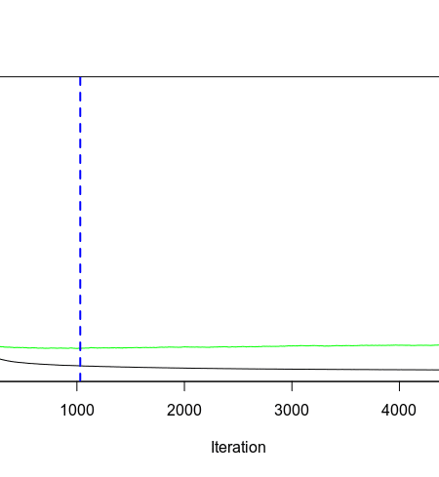](https://i1.wp.com/s3-us-west-1.amazonaws.com/alpha-analysis.com/Pictures/GBM/mse_vs_oob_5000_boost.png?ssl=1)

The fitted black curve above is MSE and the fitted green curve is the out of bag estimated error.  1183 is the optimal amount of iterations.

[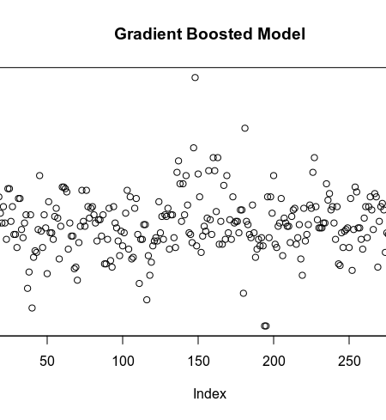](https://i0.wp.com/s3-us-west-1.amazonaws.com/alpha-analysis.com/Pictures/GBM/residuals_boosted.png?ssl=1)

[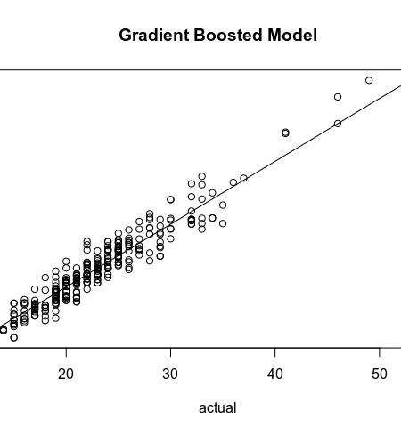](https://i1.wp.com/s3-us-west-1.amazonaws.com/alpha-analysis.com/Pictures/GBM/predict_vs_actual_boosted.png?ssl=1)

> pred_boosted_reg <- predict(m_boosted_reg,n.trees=1183, newdata = test)  
> mse_boosted_reg <- RMSE(pred = pred_boosted_reg, obs = test$fuel_economy_combined) ^2  
> boosted_stats<-postResample(pred_boosted_reg,test$fuel_economy_combined)  
> boosted_stats  
 RMSE Rsquared MAE   
1.8018793 0.9092727 1.3334459   
> mse_boosted_reg  
3.246769

The tuned gradient boosted model performs better than the random forest with a MSE of 3.25 vs 3.67 for the random forest.

> summary(res)  
 Min. 1st Qu. Median Mean 3rd Qu. Max.   
-5.40000 -0.90000 0.00000 0.07643 1.10000 9.10000

50% of the predictions are within 1 MPG of the EPA Government Estimate.

The largest residuals are exotics and a hybrid which are the more unique data points in the dataset.

> tmp[which(abs(res) > boosted_stats[1] * 3), ]   
 Division Carline fuel_economy_combined pred_boosted_reg  
642 HYUNDAI MOTOR COMPANY Ioniq Blue 58 48.5  
482 KIA MOTORS CORPORATION Forte FE 35 28.7  
39 Lamborghini Aventador Coupe 11 17.2  
40 Lamborghini Aventador Roadster 11 17.2

[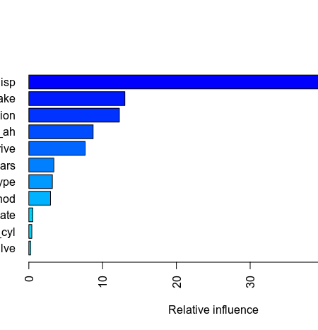](https://i0.wp.com/s3-us-west-1.amazonaws.com/alpha-analysis.com/Pictures/GBM/varImp_boosted.png?ssl=1)